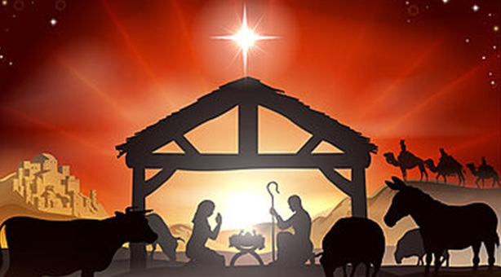

- Christmas & New Year Mass Schedule

- Nativity of our Lord
- Wednesday, December 24
- 7:00 pm – Christmas Eve Mass
- 11:30 pm – Christmas Carols followed by Midnight Mass
- (No morning mass)

- Thursday, December 25
- 11:00 am – Christmas Day Mass

- Solemnity of Mary, The Holy Mother of God
- Wednesday, December 31
- 9:00 am – Regular Mass
- 5:00 pm – New Year’s Eve Mass

- Thursday, January 1
- 9 & 11:00 am – New Year’s Day Mass
- Day of Obligation in Canada

The Parish office will be closed on:
Wednesday, December 24 – At noon
Thursday, December 25 – Christmas Day
Friday, December 26 – Boxing Day
Wednesday, December 31 – At noon
Thursday, January 1 – New Year’s Day

