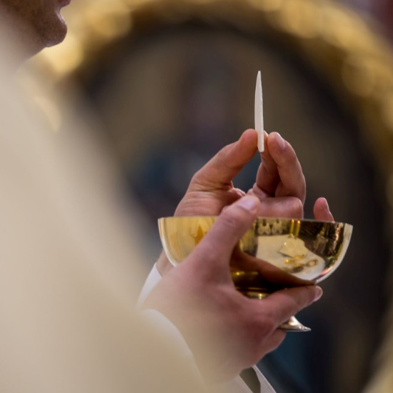

- First Reconciliation and Rehearsal for the First Holy Communion candidates will be held on Saturday, April 20, 2024 at 2:30 pm. Candidates are requested to come directly to the Church.

- The candidates will receive the sacrament of First Holy Communion on Sunday April 21 at 2:00 pm.

